Chocolate Bar 2020 use case proposal

Yifei Dong

DSBA 6520 – Network Science

Jun 11th 2021

Professor Robinson

As a Chocolate shop manager at the South Park Mall, we import and sell chocolates from all over the world from hundreds of different companies. However, after Covid-19 has started, the sales have been declining. To provide a better shopping experience and great quality for our customers, I will use graph analytics to identify few questions below using the Chocolate Bar dataset:

* Where are the best cocoa beans grown?
* Which countries produce the highest-rated chocolate bars?
* What is the most popular taste?
* Which company has highest Rate?

This dataset contains 21 columns and 2225 rows. I will use the dataset to answer these questions and determine what chocolate will be purchased from which company in the next year.

Graph data model

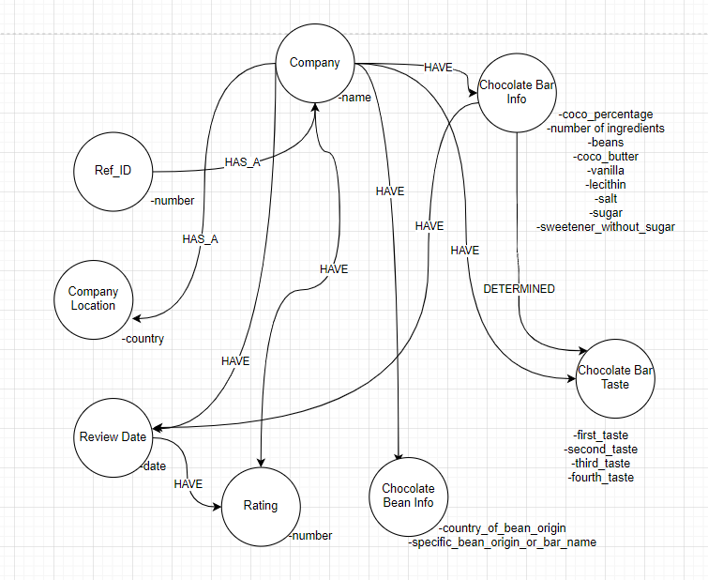

Bi-partite graph

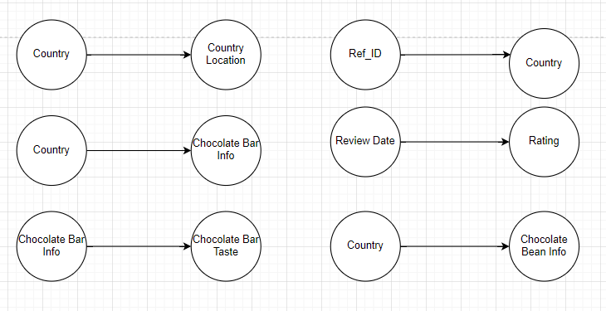

Mono-partite graph

